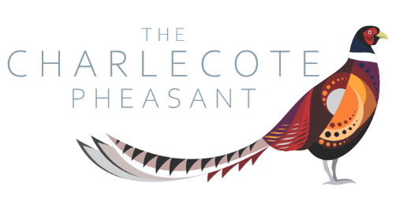
Light Bites Menu

Bread and Oils - £3.95
Olives -£4.95

Soup of the day with bread roll - £5.25
Margarita Pizza - £9.95
Pepperoni Pizza - £9.95
Fish and Chips - £12.95
Chicken Caesar Salad - £10.95

Dessert of the day - £5.95

