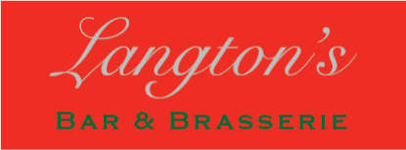

Bar Menu

Soup

Soup of the Day served with Bread & Butter £5.95
(Choice of 2 please check with server when ordering)

Sandwich Selection

Served on Your Choice of White, Brown or Malted Bread with a Garden Salad, Yorkshire Crisps & Coleslaw.
Mature Cheddar Cheese, Langton’s Chutney £5.95
Tuna Mayonnaise, Cucumber £5.95
Tomato or Cucumber, Cream Cheese £5.25
Egg Mayonnaise, Mustard Cress £6.25
Honey Roast Ham, Grain Mustard £6.95
Roasted Yorkshire Beef, Horseradish £6.95
Prawn & Crayfish, Spiced Marie Rose £6.95
Smoked Salmon, Cream Cheese £6.95

Toasted Sandwich Selection
Served on Your Choice of White, Brown or Malted Bread with a Garden Salad, Yorkshire Crisps & Coleslaw.
Honey Roast Ham & Mature Cheddar Cheese £7.50
Mature Cheddar Cheese & Tomato £6.95
Triple Decker BLT, Garden Herb Salad Mayonnaise £8.95

Sides

Skinny Fries £2.95
Chunky Chips £2.95
Mixed Salad £3.50

Although the utmost care is taken, we cannot guarantee that our food is 100% free from allergens. Please ask for further assistance.

