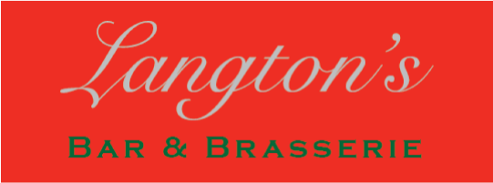

Pizzas & Garlic Bread

Pizza Menu

All pizzas are 12’’

Margherita £9.95
Classic Cheese and Tomato

Pepperoni £13.95
Pepperoni, Mushrooms, Red Onion and Olives

Vegetarian £13.95
Mushrooms, Red Onion, Mixed Peppers, Fresh Mozzarella, Olives & Sundried Tomatoes

Hot and Spicy £14.35
Chorizo, Jalapenos, Red Onion, Pepperoni and Garlic

Vegetarian: Hot £13.95
Mushroom, Sweetcorn, Jalapeno, Onions, Mixed Peppers and Garlic

If you would like to add more items (charge per item)
Mushrooms, Red Onion, Mixed Peppers, Jalapenos, Sweetcorn, £1.00
Sundried Tomatoes, Olives, Fresh Mozzarella

Pepperoni, Chorizo, Ham, £1.50
***
Garlic Bread

Cheesy Tomato Garlic Bread £9.45
Garlic and Herb Bread £7.95

Available from Midday Onwards

Although the utmost care is taken, we cannot guarantee that our food is 100% free from allergens, please ask for further assistance.

